Saxon Engineering
23, Heath Street, Lonsdale, 5160, South Australia. Phone: (08) 8187 2888, Email: Sales@saxonengineering.com.au

PLINTH SURROUNDS
ORDER FORM/ REQUEST FOR QUOTATION
YOUR DETAILS: DATE:
Business/ Company Name:_____________________ | ABN ______________________________________
Address:_____________________________________ | P.O Number:________________________________
____________________________________________ | FAX:_______________________________________
Delivery Address______________________________ | Email:______________________________________
____________________________________________ | Contact Person:_____________________________
Phone:______________________________________ | Position:___________________________________
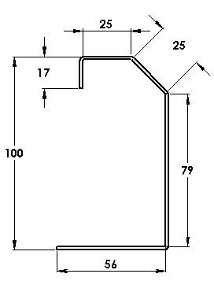
Signature:__________________________________
Figure 1sdfsd
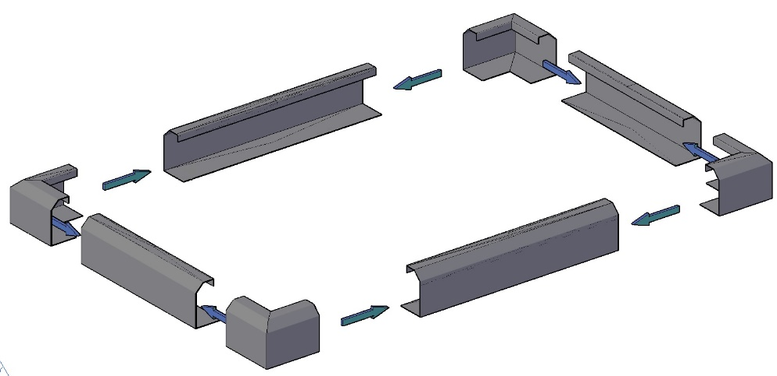

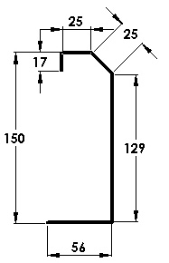
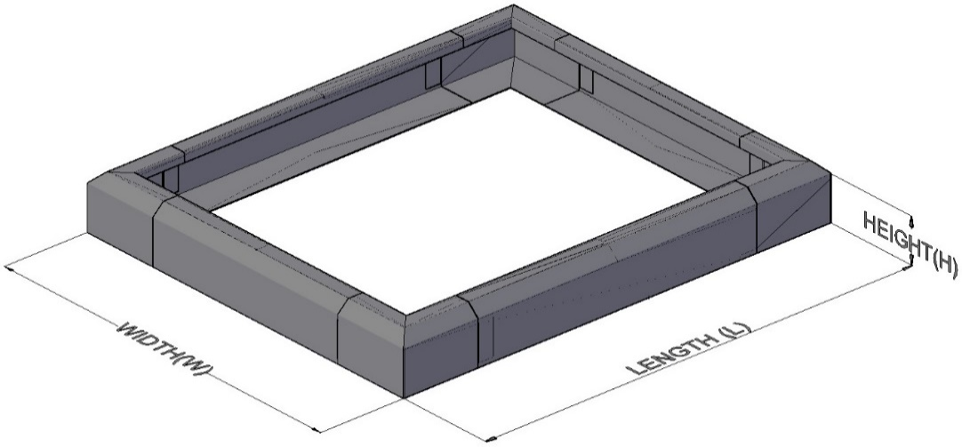
Type A Height in mm (100)

`

BMT= 1.6mm, GALVABOND Type B Height in mm (150)
S.No | Style  Flatpacked (F)/  Fully Assembled(A) | Dimensions |  |  | Quantity  (Q) | Unit Price  (P) | Total Price  (QxP)
 |  | L | W | Type A(90mm) /B(135mm)
E.G | F | 1000 | 800 | A | 5

